import java.util.Scanner;

public class FitChecker {

public static void main(String[] args) {

Scanner sc = new Scanner(System.in);

int t = sc.nextInt();

for (int i = 0; i < t; i++) {

String input = sc.next();

try {

long num = Long.parseLong(input);

System.out.println(input + " can be fitted in:");

boolean canFit = false;

if (num >= Byte.MIN_VALUE && num <= Byte.MAX_VALUE) {

System.out.println("* byte");

canFit = true;

}

if (num >= Short.MIN_VALUE && num <= Short.MAX_VALUE) {

System.out.println("* short");

canFit = true;

}

if (num >= Integer.MIN_VALUE && num <= Integer.MAX_VALUE) {

System.out.println("* int");

canFit = true;

}

if (num >= Long.MIN_VALUE && num <= Long.MAX_VALUE) {

System.out.println("* long");

canFit = true;

}

if (!canFit) {

System.out.println(input + " can't be fitted anywhere.");

}

} catch (NumberFormatException e) {

System.out.println(input + " can't be fitted anywhere.");

}

}

}

}

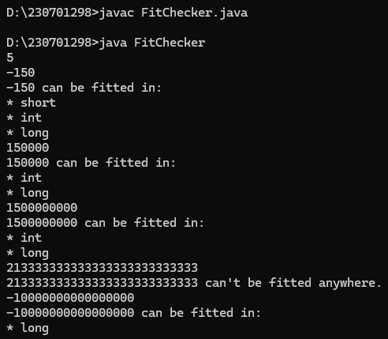

import java.util.*;

public class cents

{

public static void main(String args[])

{

Scanner sc = new Scanner(System.in);

int cents = sc.nextInt();

double cent = cents;

double dollars = cent/100;

System.out.printf("%.2f", dollars);

}

}

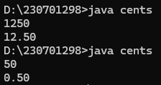

import java.util.*;

public class scores

{

public static void main(String args[])

{

Scanner sc = new Scanner(System.in);

double score = sc.nextDouble();

int Score = (int) score;

System.out.println(Score);

}

}

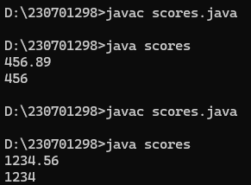

import java.util.*;

public class salary

{

public static void main(String[] args) {

Scanner sc = new Scanner(System.in);

int salary = sc.nextInt();

double interest = sc.nextDouble();

double newSalary = salary+(salary * (interest*0.01));

System.out.println(newSalary);

}

}

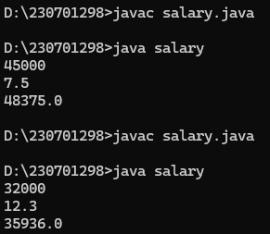

import java.util.*;

public class reverse

{

public static void main(String args[])

{

Scanner sc = new Scanner(System.in);

int num = sc.nextInt();

int rem = 0, rev = 0;

while(num!=0)

{

rem = num%10;

rev = rev*10 + rem;

num /= 10;

}

System.out.println(rev);

}

}

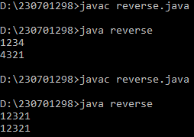

import java.util.Scanner;

public class DiamondPattern

{

public static void main(String[] args)

{

Scanner sc = new Scanner(System.in);

int n = sc.nextInt();

for (int i = 1; i <= n; i++)

{

for (int j = i; j < n; j++)

System.out.print(" ");

for (int k = 1; k <= (2 * i - 1); k++)

System.out.print("*");

System.out.println();

}

for (int i = n - 1; i >= 1; i--) {

for (int j = n; j > i; j--)

System.out.print(" ");

for (int k = 1; k <= (2 * i - 1); k++)

System.out.print("*");

System.out.println();

}

}

}

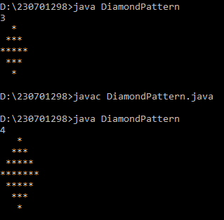

import java.util.Scanner;

public class PascalHalfDiamond {

public static void main(String[] args) {

Scanner sc = new Scanner(System.in);

int n = sc.nextInt();

sc.close();

int[][] p = new int[n][];

for (int i = 0; i < n; i++) {

p[i] = new int[i + 1];

p[i][0] = 1;

p[i][i] = 1;

for (int j = 1; j < i; j++) {

p[i][j] = p[i - 1][j - 1] + p[i - 1][j];

}

}

for (int i = 0; i < n; i++) {

int spaces = (n - i - 1);

for (int j = 0; j < spaces; j++) {

System.out.print(" ");

}

for (int j = 0; j <= i; j++) {

System.out.print(p[i][j] + " ");

}

System.out.println();

}

for (int i = n - 2; i >= 0; i--) {

int spaces = (n - i - 1);

for (int j = 0; j < spaces; j++) {

System.out.print(" ");

}

for (int j = 0; j <= i; j++) {

System.out.print(p[i][j] + " ");

}

System.out.println();

}

}

}

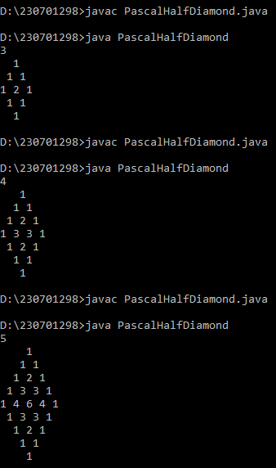

import java.util.*;

public class series

{

public static void main(String args[])

{

Scanner sc = new Scanner(System.in);

int q = sc.nextInt();

while(q>0)

{

int a = sc.nextInt();

int b = sc.nextInt();

int n = sc.nextInt();

int d = 0;

while(d<=n)

{

int sum = a;

for(int i=0; i<d; i++)

sum += Math.pow(2, i)*b;

System.out.print(sum + " ");

d++;

}

q--;

}

}

}

